|  |  |  |  |  |  |
| --- | --- | --- | --- | --- | --- |
| Date | 12-Dec-22 | | | Tester Name | Janette Paus |
| Environment | Penfax - Test 2 | | | Login used | <If different from the Tester> |
| Operating System | Windows | Version: 21H2 | Update Number: | | |
| Software Used | Select Software | Version: 107.0.1418.56 | Update Number: | | |
| Select Software | Version: | Update Number: | | |
| Application Release version | R22.4.1 | | | | |
| Test Case Title | E13.16c | | | | |
| Test Type | Regression | | | | |
| Test Scenario | Confirm you cannot add a non-spouse primary beneficiary, if married status is married in PENFAX - PENWEB | | | | |
| Expected Results | The non-spouse beneficiary cannot be added if member is married in PENFAX | | | | |
| Pass/Fail | Pass | | | JIRA# |  |

Search for a member to remove a beneficiary through PENWEB

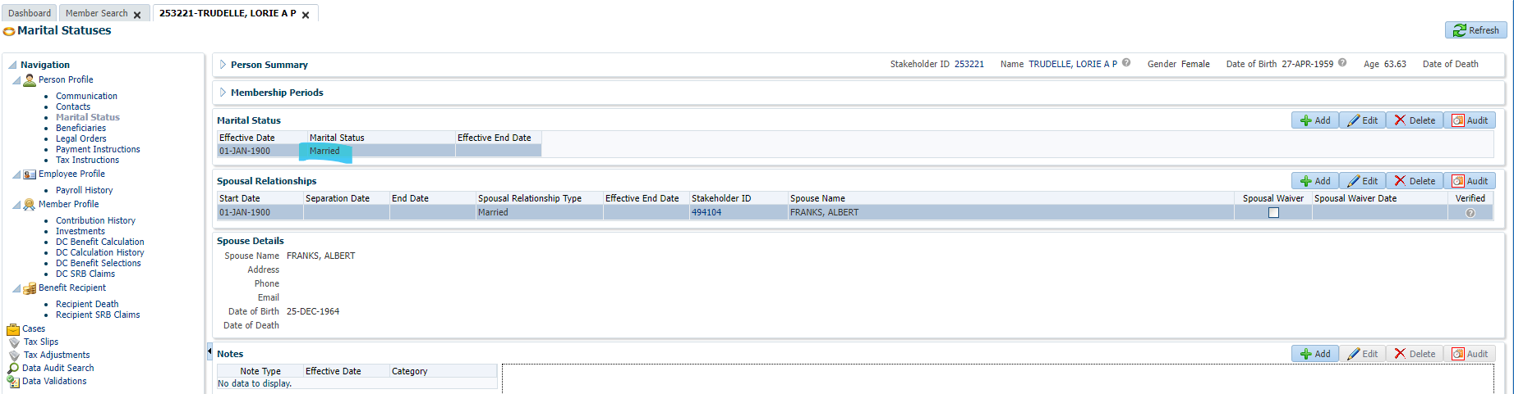

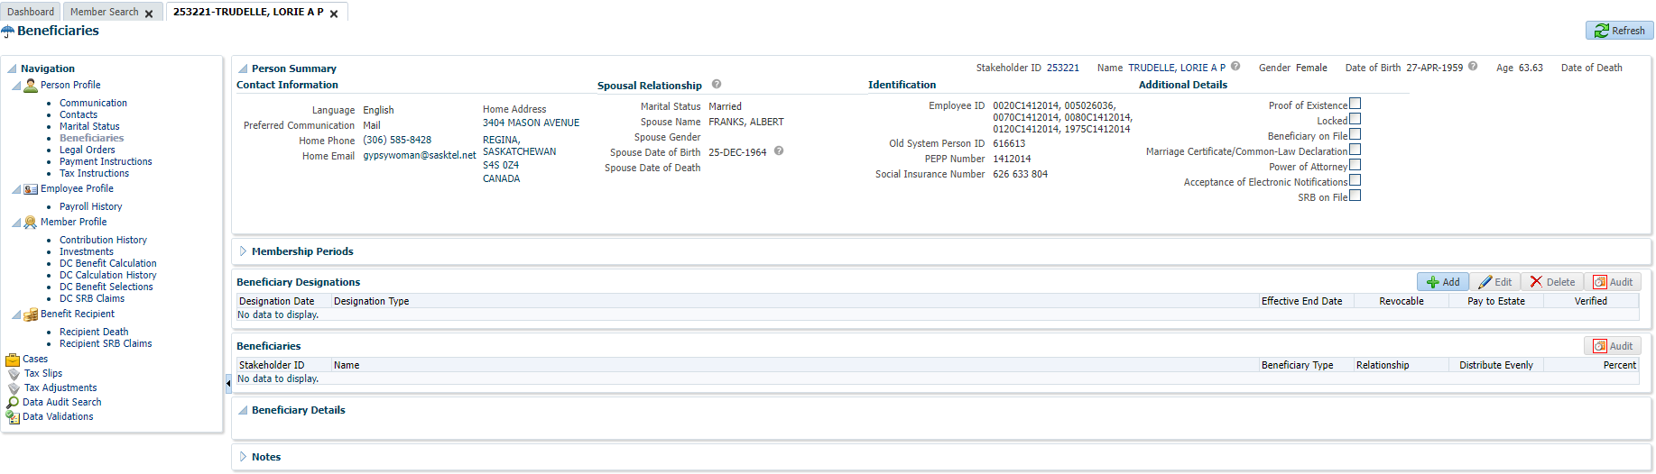

Open that member in Planet member PEPP



Go to Beneficiary Tab

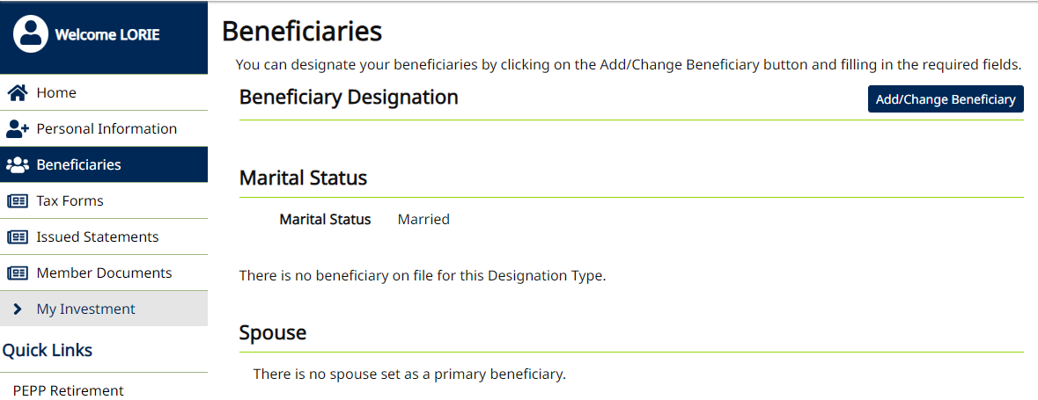

Under Beneficiary tab, add/change Beneficiary

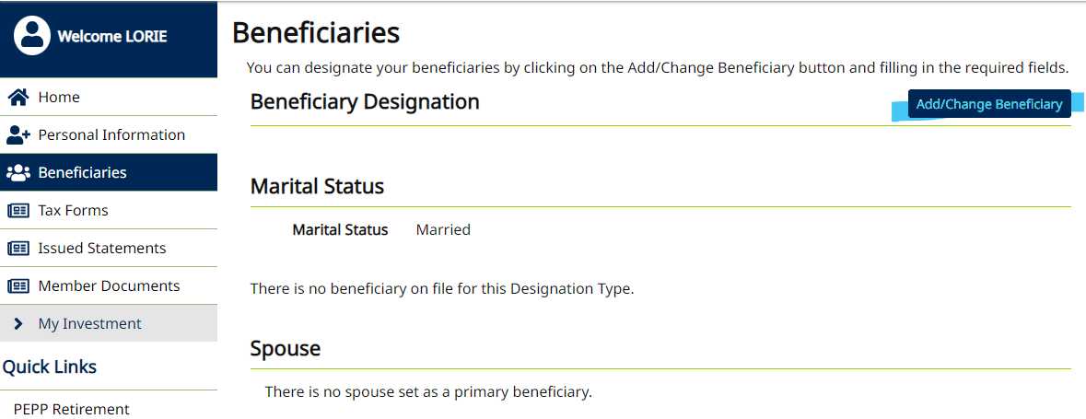

The system automatically added the spouse as the beneficiary because the member is married.

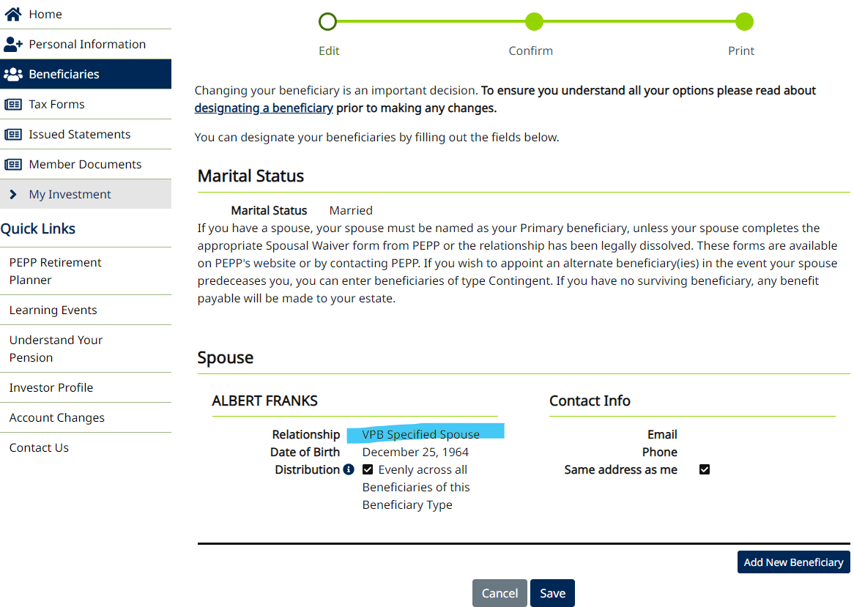

Click Add New Beneficiary

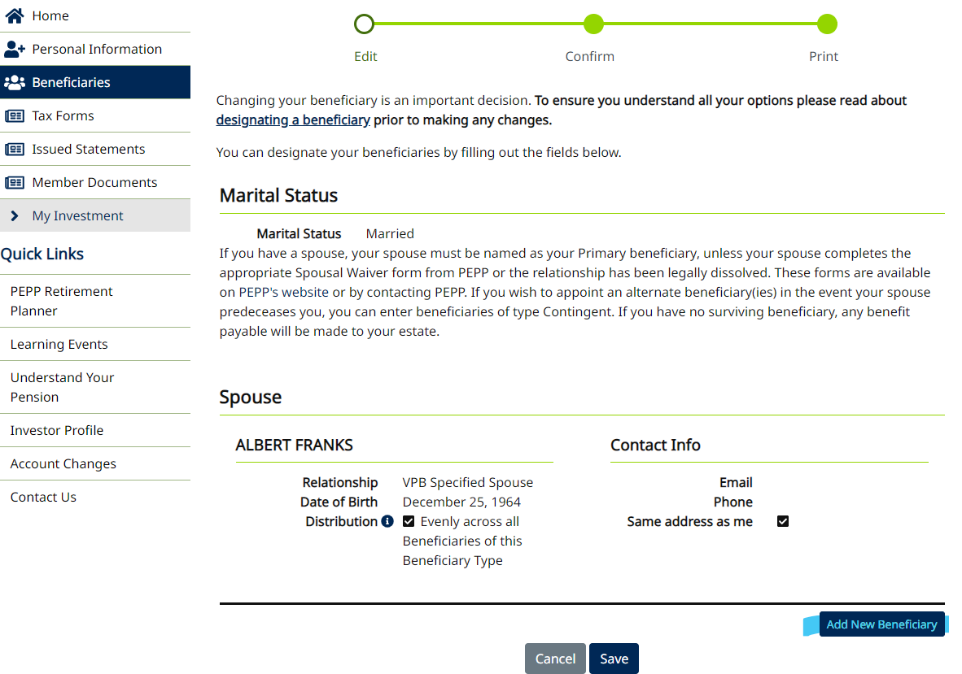

Select Person or Organization

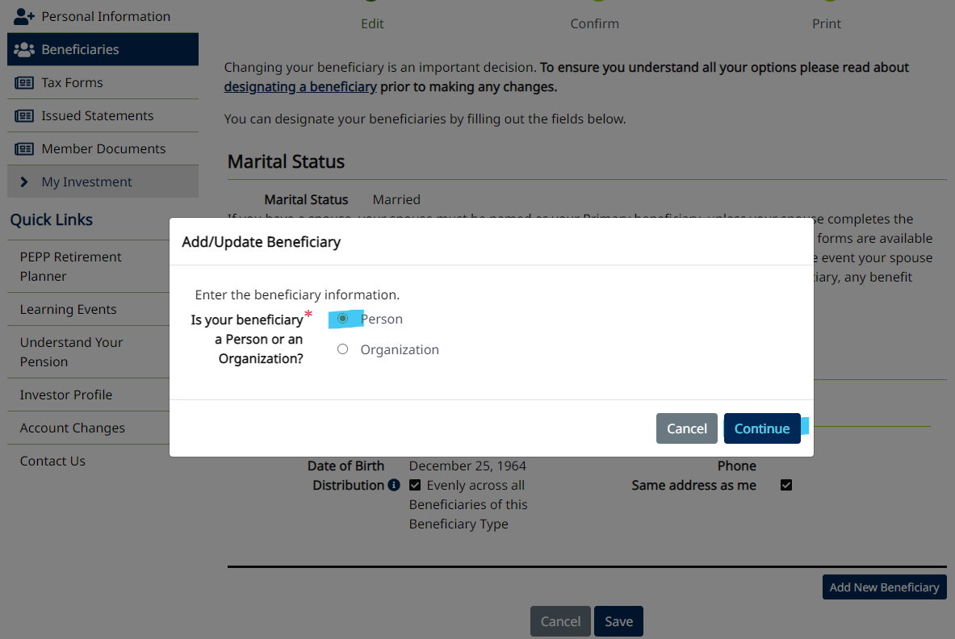

Enter details and Save

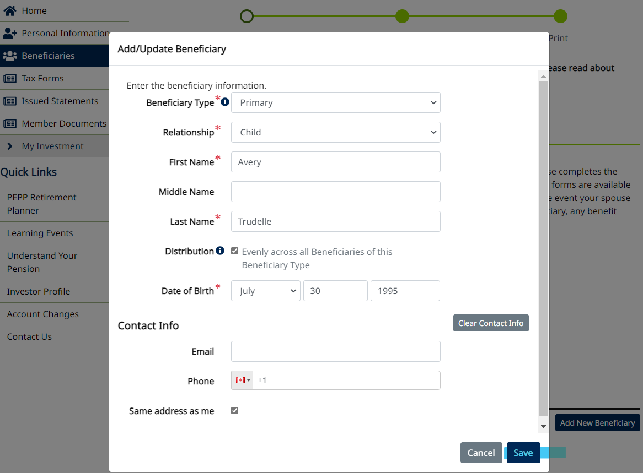

Save

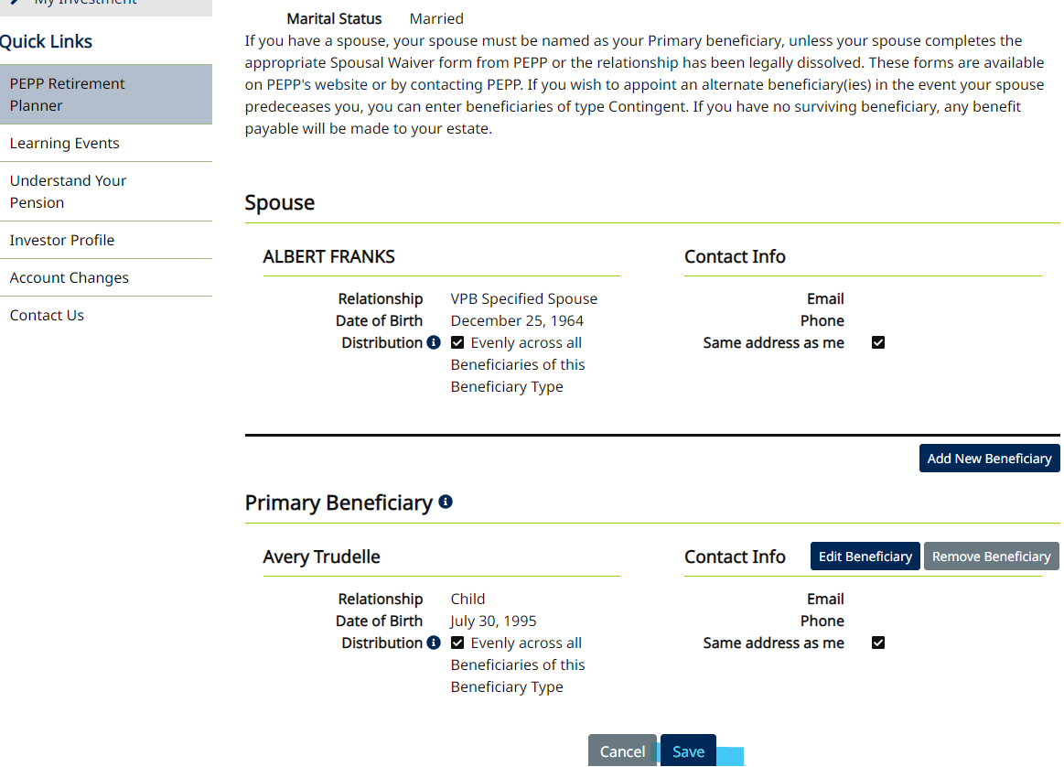

Confirm addition

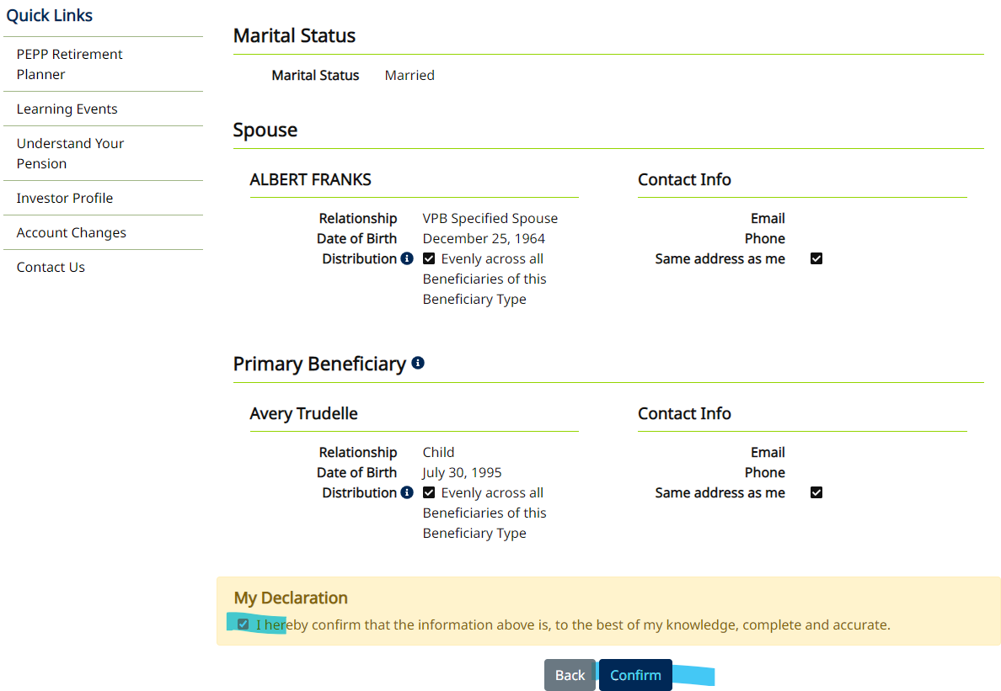

Received error message:

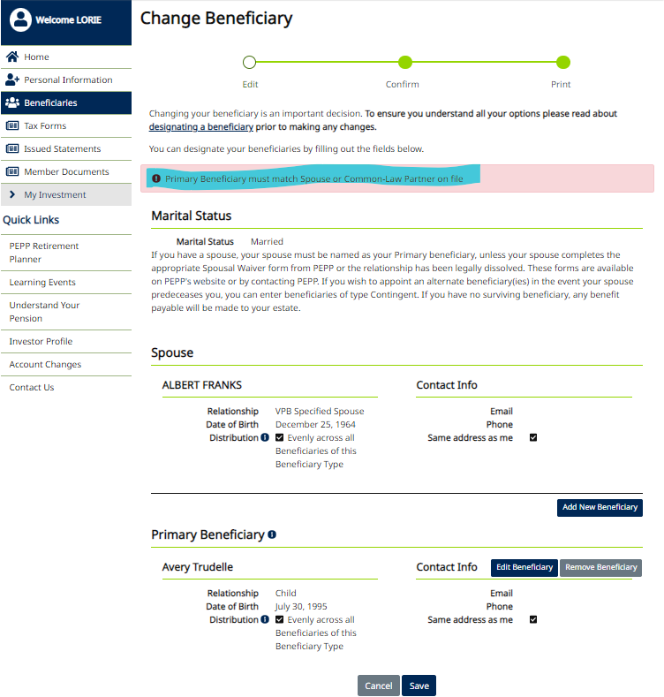

Therefore, a non-spouse primary beneficiary cannot be added in PENWEB if the member is showing married in PENFAX.